1. Today we will learn

* Operators
* If else
* Loops

1. 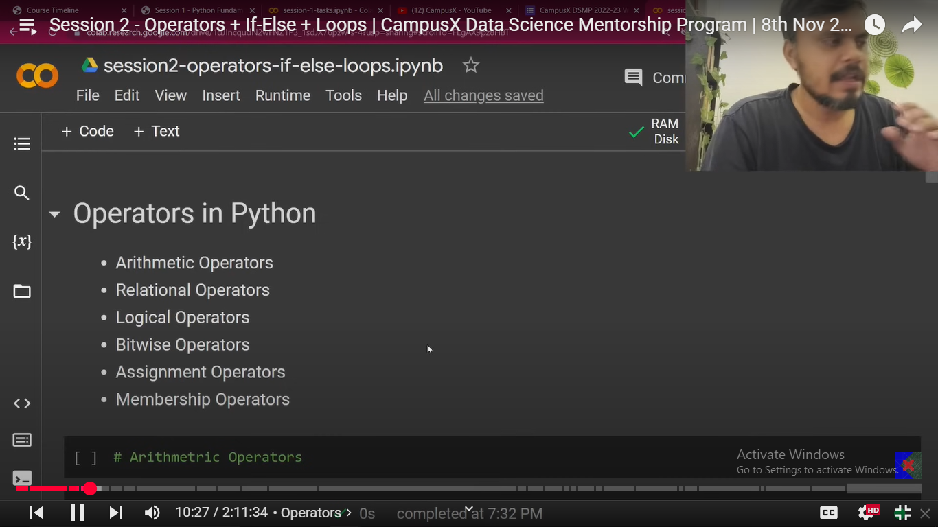
2. Please note in case of Membership operators: in/not in works on string, list, set, tuple,dictionary which becomes really helpful.
3. Till 1:15 mins completed
4. **Module**: Module in simpler terms is basically a file which contains several function written by someone else. We just use the functions present in it. Basically, it helps us to make our job easier and also follow the principle of code reusability.
5. Modules that we are going to learn today are:
   1. math
   2. keywords
   3. random
   4. datetime
6. To import a module:
   1. import **math**
   2. math.factorial(5) //120
   3. math.floor(5.6) //5
   4. math.sqrt(144) // 12.0

Basically this math module contains everything which is required to create a mathematical software.

1. Let’s learn **keyword** module:
   1. Let’s say I want to know the list of keywords i.e reserved words by python.
   2. Import keyword
   3. Print(keyword.kwlist) //This will give you the list of all the keywords.
2. Let’s see **datetime** module:

Import datetime

**datetime.datetime.now()** //This will give you current day’s date and time.

To know more about this module just see what are the functions available here.

1. Also let’s say if you want to see what are the modules available in python just write:

help(‘modules’) // It will list you down all the modules available and also you can do the same for each module to understand what is the module all about. Also you can get assistance using the same help function if you want to know about a specific module.

1. **Loops in Python**

There are basically 2 types of loops in Python:

while loop

for loop

We will understand each of them separately through examples:

You can go to the google collab notebook to see those examples.

We executed our first code to print table using a number.

If you want to see your code running Step by Step there is a website called pythontutor.com -> select Python as a program ->

Then paste your code and click visualization -> and then run it step by step. You will get to learn the exact flow of the code. This really helps to understand the flow of the code.

Remember along with loops we can use a concept of else like

While condition:

Code

else:

code

How does this operate is till the condition is true it will run the code present in while but the moment condition goes to False it will just to the else block and execute it and will come out of the loop.

To see example: go to Google Colab notebook

1. Range() function:

range() generates number within a given range which means,

**range(1,11)** This will give you 1,2,3,4…,10. It will exclude 11 till 10 it will consider.

1 is Starting range

11 is ending range.

We can also write it like: **range(1,11,2)**

1 is Starting range

11 is ending range

2 is the stepping size

Which means it will give numbers : 1,3,5,7,9

Similarly range(1,11,3) // 1,4,7,10

Let’s say someone tells you to print numbers from 10 to 1 in reverse.

for i in range(10,0,-1):

print(i)

10 is starting range

0 end range which means will cover till 1

-1 is the stepping size.

We can also interate in for loops not only in integer but also in string,list,tuple,set,dictionary.

for i in ‘delhi’:

print(i)

for i in [1,2,3,4]:

print(i)

for i in (1,2,3,4):

print(i)

for i in {1,2,3,4}:

print(i)

and dictionary as well.